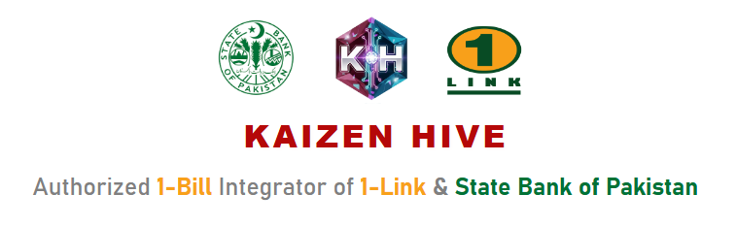

Task 1: Create a GET Route
Task Statement: Using Node.js with Express or any backend framework, create a GET route /hello that returns the text Hello Web Developer.
Input:
Request: GET /hello
Expected Output:
Hello Web Developer

Solution:
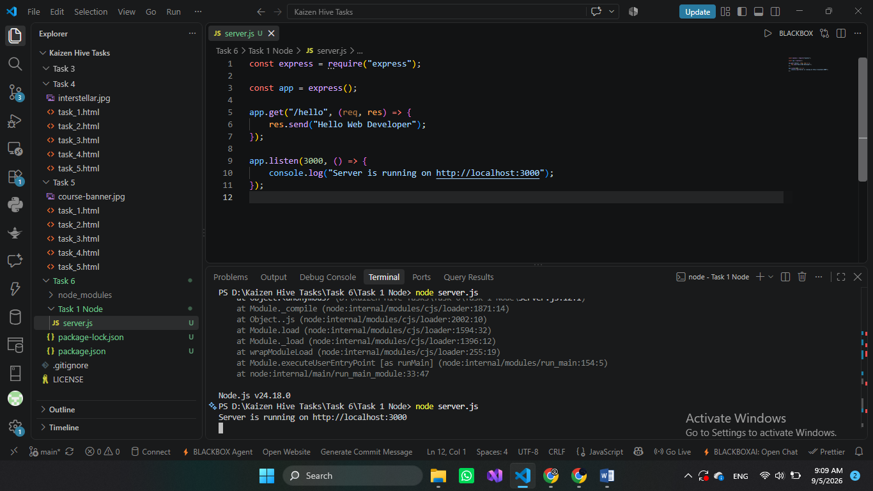
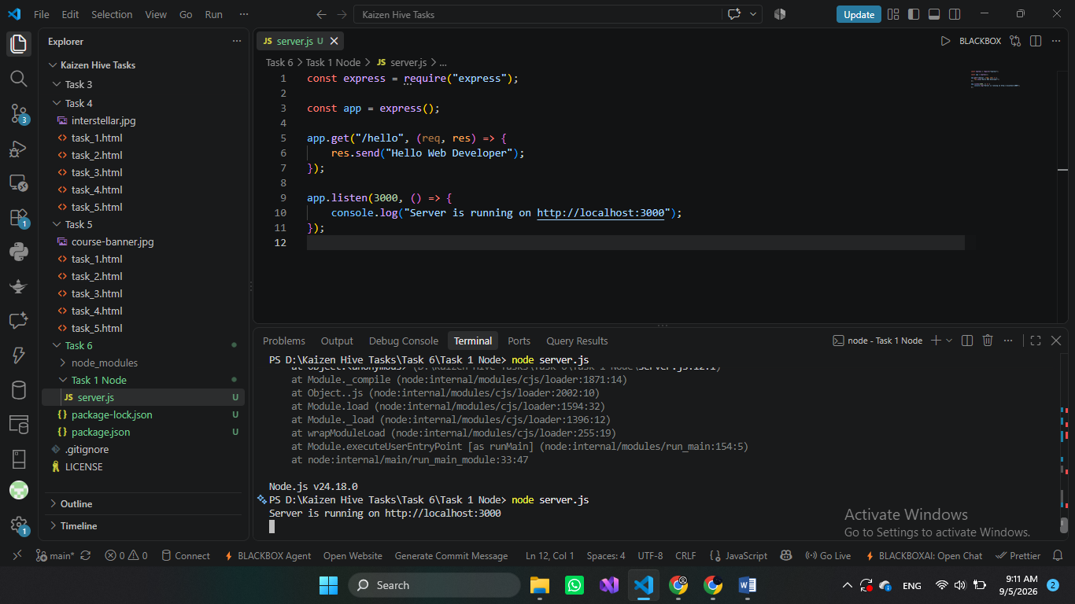
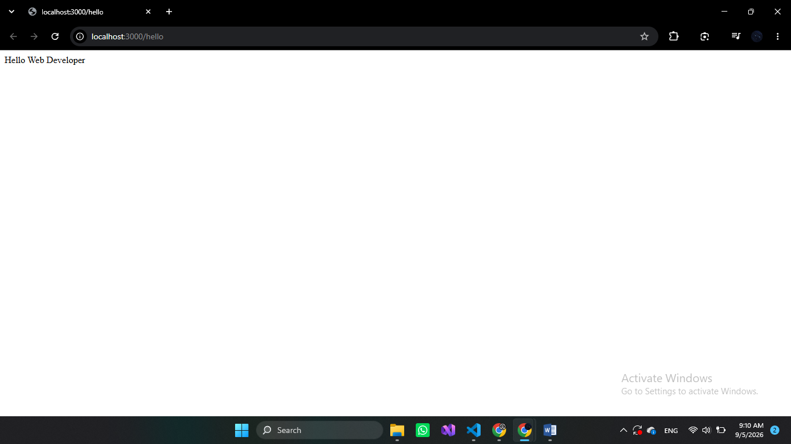

Task 2: Route Parameter Example
Task Statement: Create a backend route /user/:name that reads the name from the URL and returns a welcome message containing that name.
Input:
Request: GET /user/Ali
Expected Output:
Welcome Ali

Solution:
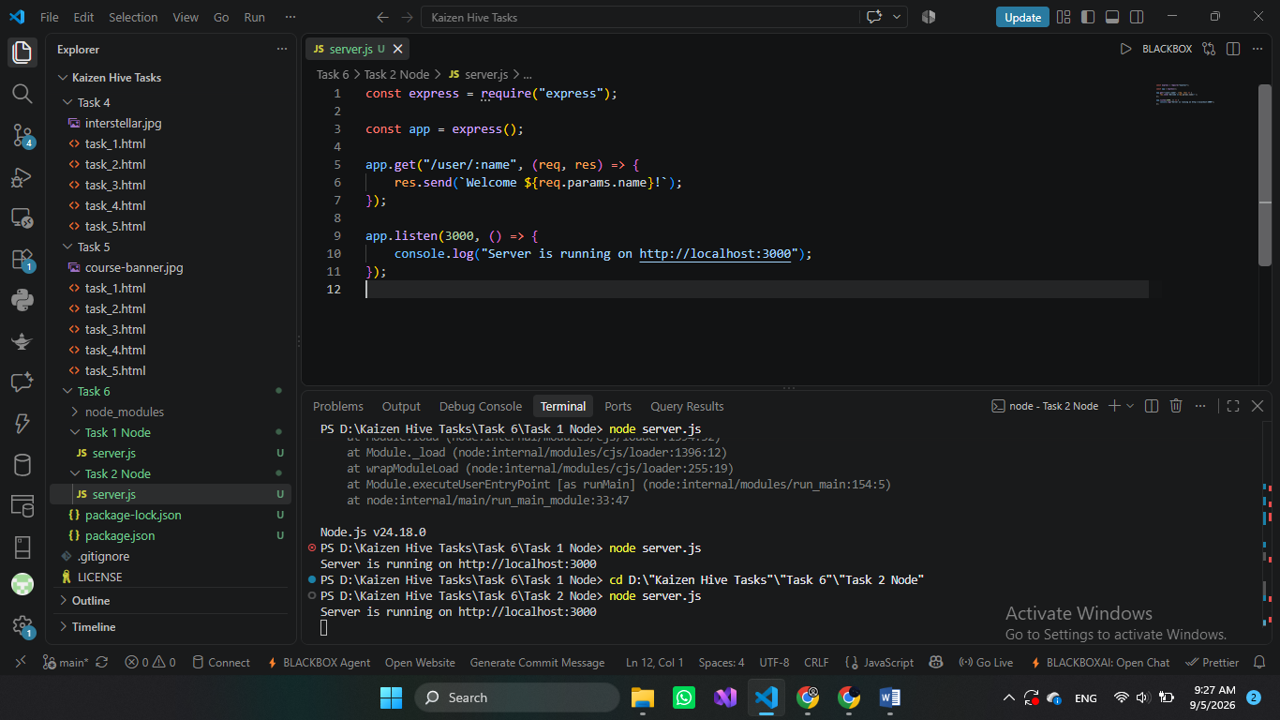

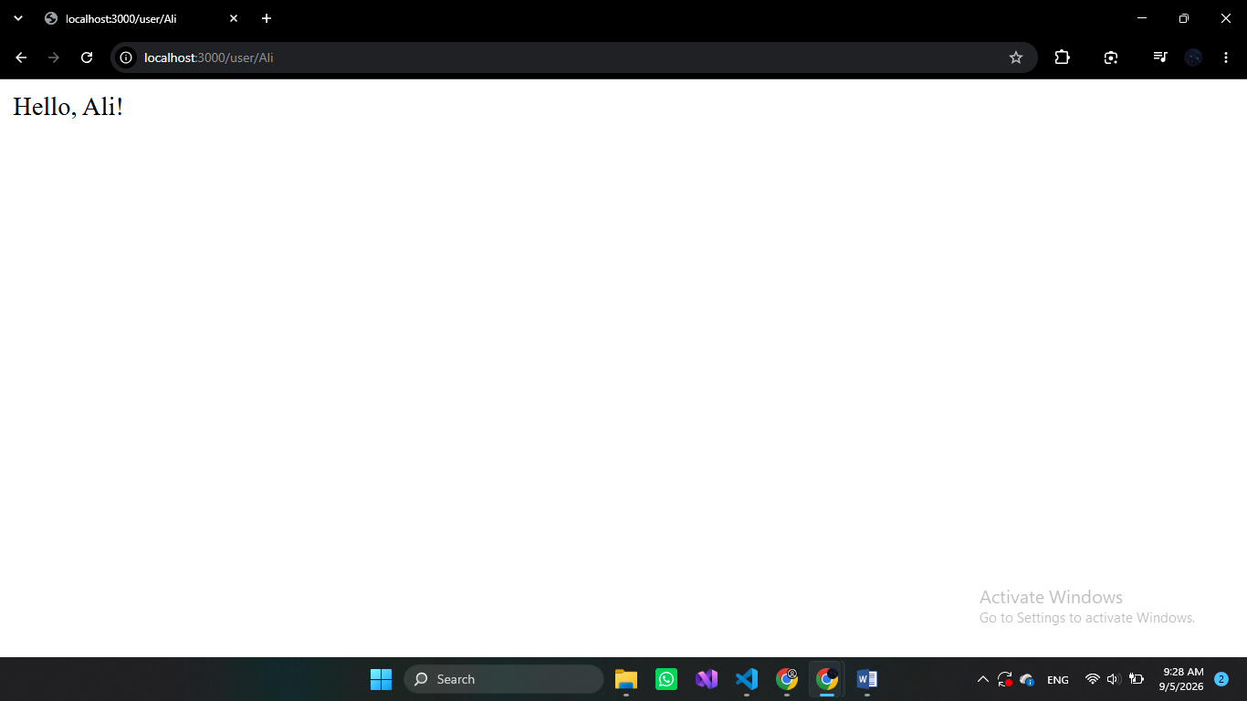

Task 3: Simple Calculator API
Task Statement: Create a backend route /add that accepts two query parameters a and b and returns their sum.
Input:
Request: GET /add?a=5&b=7
Expected Output:
Sum: 12

Solution:
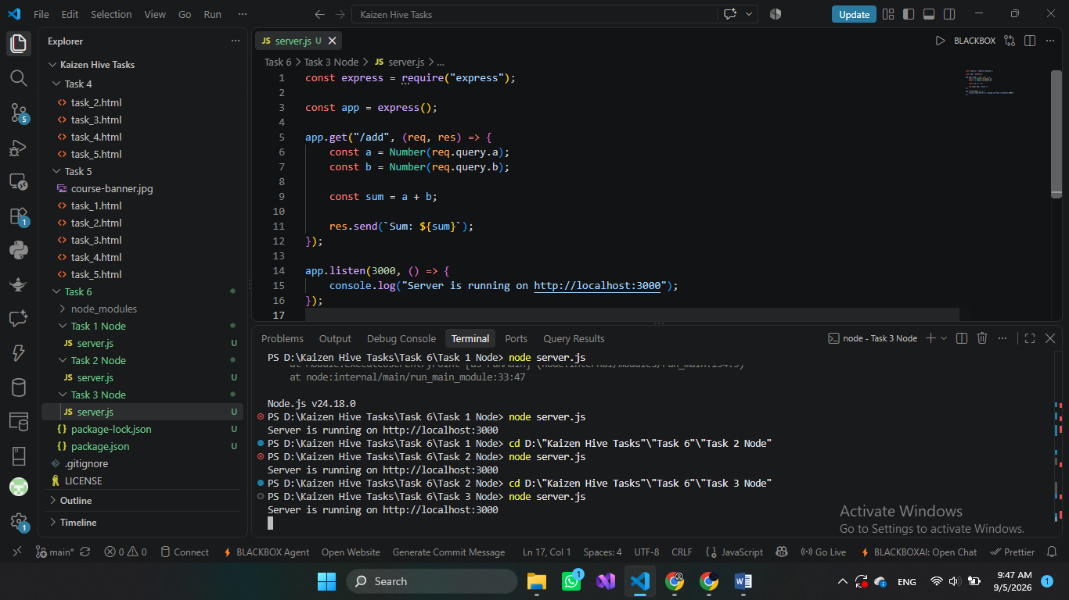

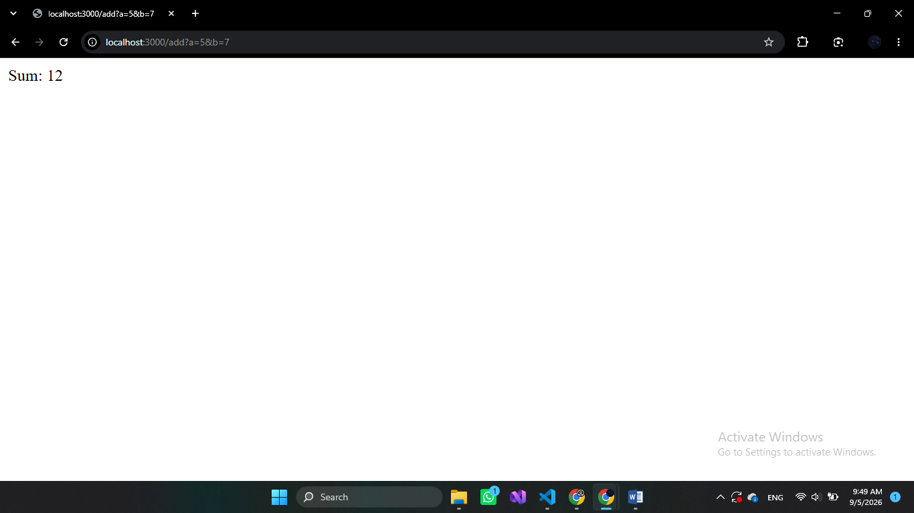

Task 4: POST Form Data Receiver
Task Statement: Create a POST route /submit that receives a name value from a form or JSON body and returns a confirmation message.
Input:
POST Body: {"name":"Sara"}
Expected Output:
Form submitted by Sara

Solution:
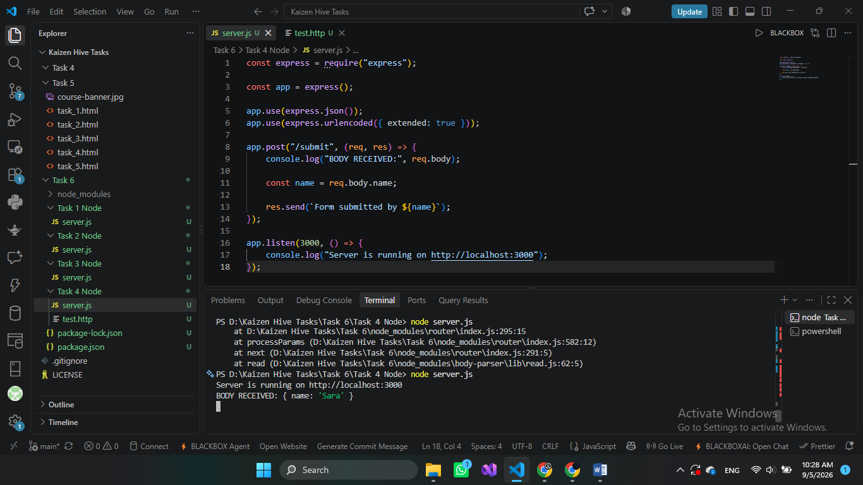

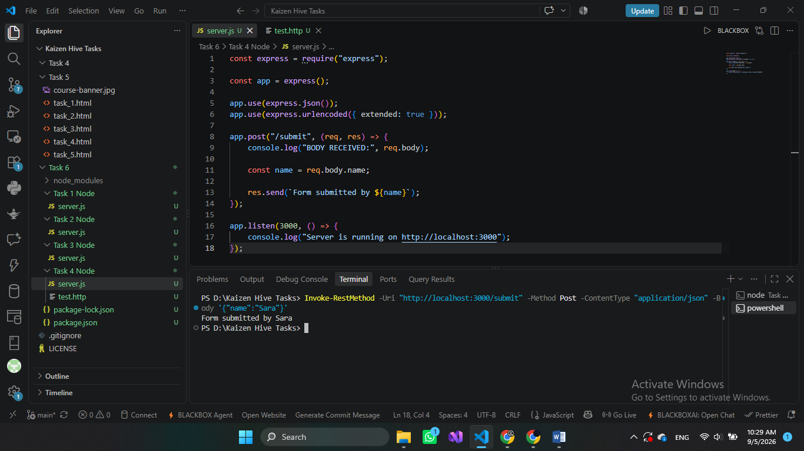

Task 5: Serve a Static HTML File
Task Statement: Create a backend application that serves a static index.html file from a public folder when the user opens the root URL.
Input:
Request: GET /
Expected Output:
The browser displays the content of public/index.html

Solution:
